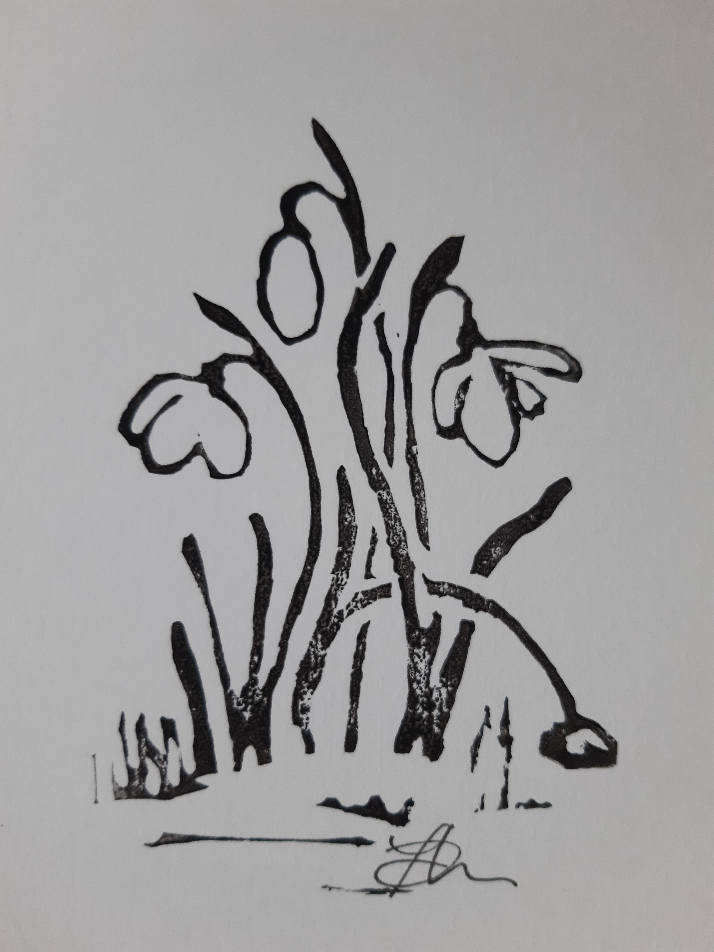

**Snowdrops**

*At first unseen, 'til cold soil parts. It's then that transformation starts.*

*Protected petals snugly wrapped emerging from their lair, Point skyward, brave, emboldened, undeterred by icy air.*

*With grace they stretch and curve their necks to dangle, bow and flex. Unfurling blooms, three swathes of white, form hanging hoods, a precious sight. Chilly breezes cause vibration, oscillating stems. Quivering their lantern tops; January's gems.*

*Then swollen pods on arching rods head back toward the ground. Casings rot. Seeds drop. Fertility abounds.*

Lino cut & poem by Fen D'Lucie